**Guide for installing STS IDE (Spring Tools Suite) and MySQL Server Database.**

**Note-** This guide is for Windows. For macOS users, perform the equivalent steps.

**STS IDE (Spring Coding Environment) Installation.**

**Note-** This is not an installation. Instead, we need to download a zip file, unzip it in an appropriate directory on our computer, and we are ready to go. IDE stands for Integrated Development Environment.

1. Go to Spring Website using the following URL:

<https://spring.io/tools/>

Pick the correct STS version for your operating system. There are downloads available for the main three operating systems.

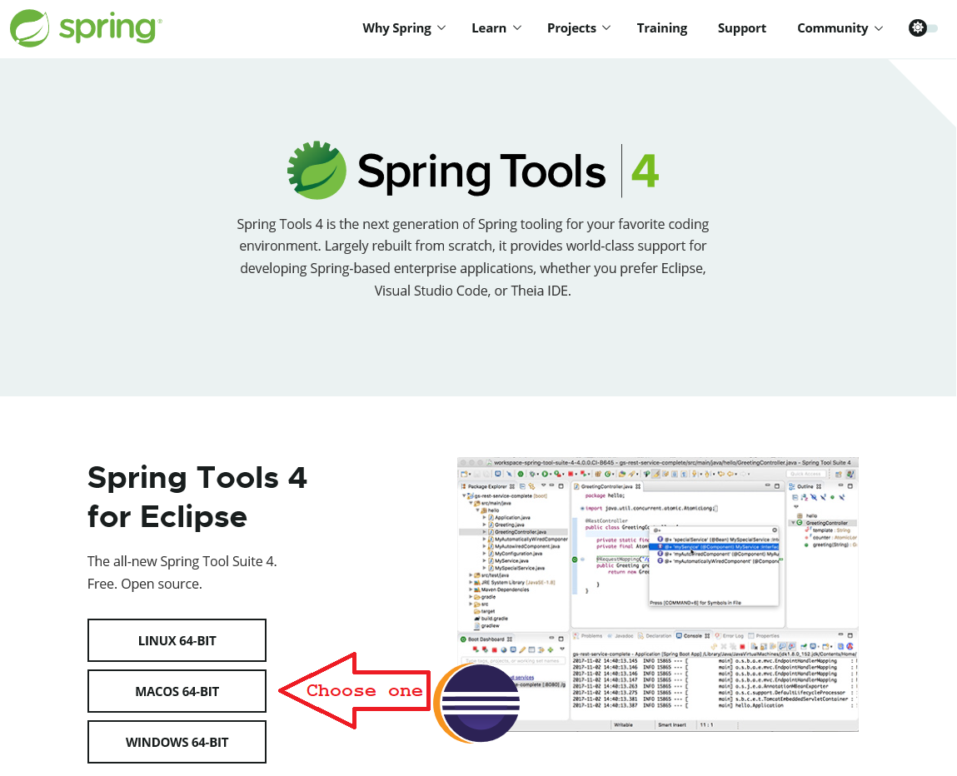

1. Once you complete the file download, unzip it in a folder you can write in. Next, unzip the file named contents.zip that you will find in the first file.
2. Navigate into the directory structure created in the previous step. Inside the folder “*sts-4.7.1.RELEASE,”* there is a file called SpringToolSuite4.exe. Execute this file, and you will get a popup window that asks for a workspace name. The workspace is just a folder in your file system where you will store your STS projects. You can use the default workspace suggested by STS, but we recommend providing a workspace folder where you know your projects will be safe. In the following example, I am creating the workspace in Drive D, but you are free to choose the folder of your convenience.

**Important Note-** Do not use the same workspace with eclipse IDE. We recommend creating a new workspace for STS IDE. The reason why is because there may be conflicts when you open with STS projects created with eclipse and vice versa. Remember that eclipse’s projects are different from STS projects even though STS is based on eclipse’s architecture.

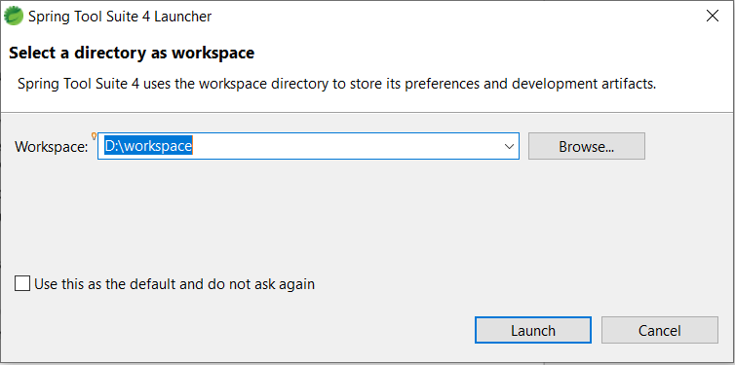

1. Finally, complete the steps detailed in the “*4 - BusyQA - STS 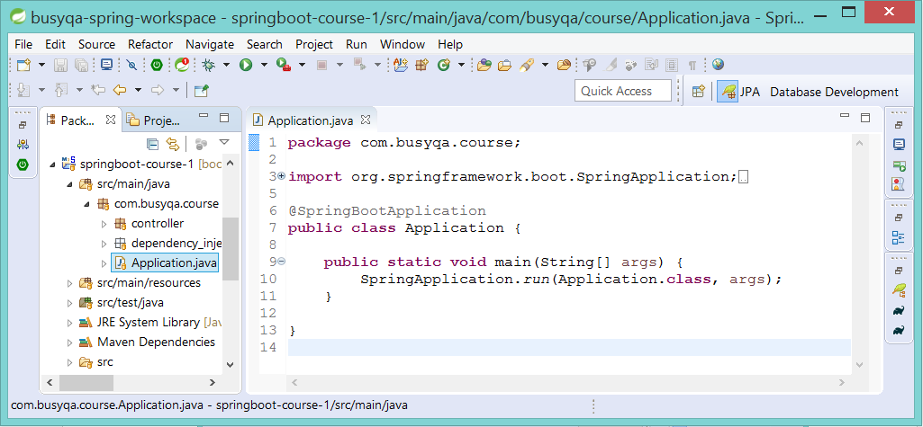Setup*” document to set up the JDK (Java Platform) in STS IDE.

**MySQL Community Server Installation.**

1. Download the MySQL Community Server.
   1. Go to the following URL:

<https://dev.mysql.com/downloads/mysql/>

Choose the correct MySQL version for your Operating System. There are downloads available for the main operating systems. To install this product on Microsoft Windows, go ahead with the next step. For Instructions for macOS, jump to step 1.3.

* 1. **For Microsoft Windows:** 
     1. Choose **Microsoft Windows** from the drop-down list. Then, hit the “Go to Download Page” button to download the MySQL Installer MSI. There are other downloads available, yet the “Installer MSI” is the easiest way to install MySQL.

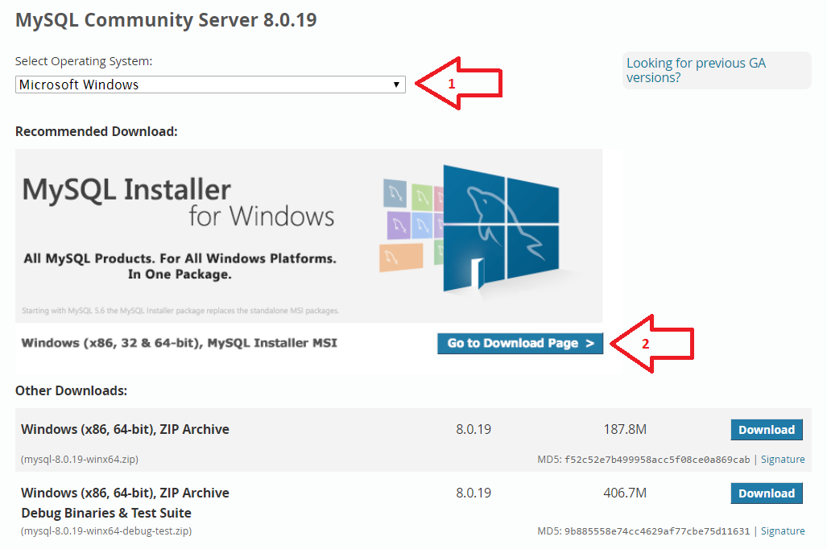

* + 1. Hit the “*Download*” button that references the biggest MySQL Installer MSI. This 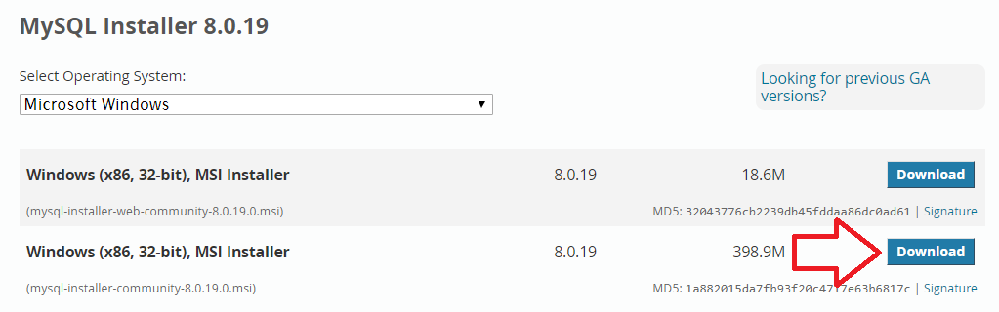installer performs an offline installation while the other an online installation.
    2. Hit the “*No thanks, just start my download*” link to start with the installer’s download. It’s unnecessary to sign in or sign up to download this product.

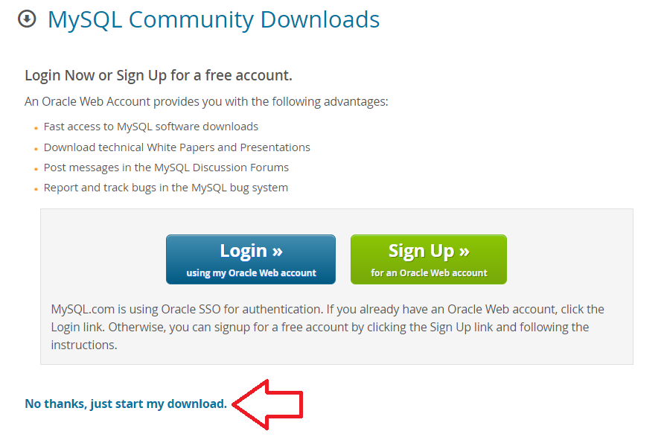

* 1. **For macOS:** 
     1. Choose **macOS** from the drop-down list. Then, hit the “*Download*” button to download the DMG Archive of the MySQL Installer.

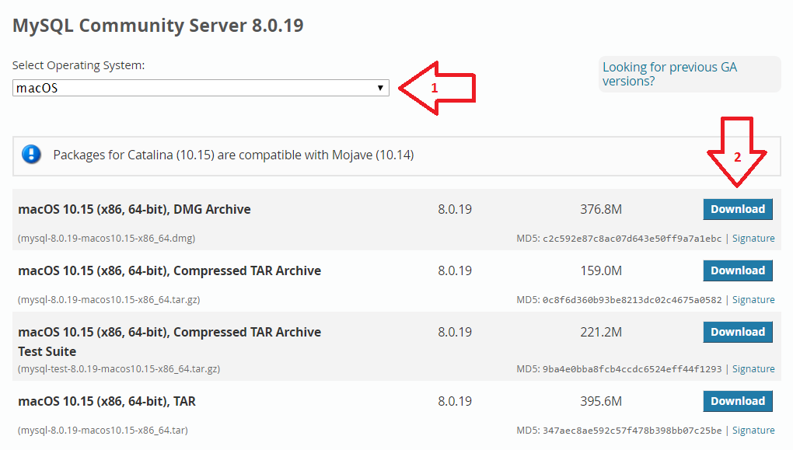

* + 1. Hit the “No thanks, just start my download” link to start with the installer’s download. It’s unnecessary to sign in or sign up to download this product.

1. Install MySQL Server on your computer:
   1. Execute the installer downloaded in the previous step. Next, select the “*Custom*” option. This option allows us to choose the MySQL components that we need. Hit “*N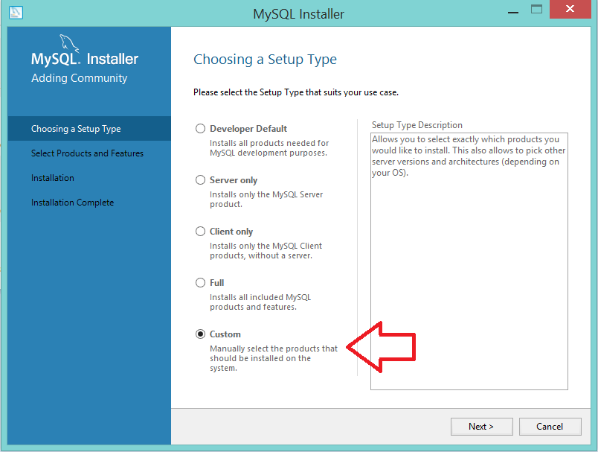ext”*.
   2. Select the MySQL components pointed by the red arrows. Hit “*Next*.”
   3. 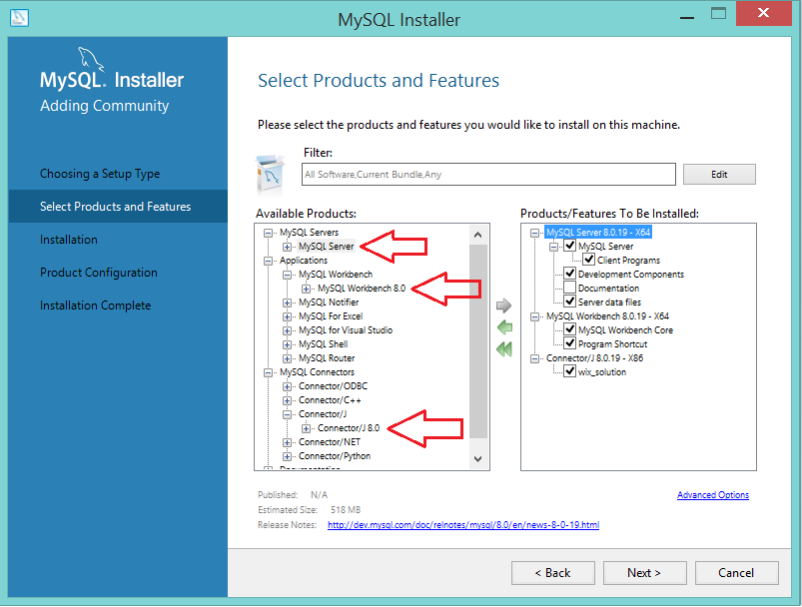The installer will show you the MySQL components about to be installed on your 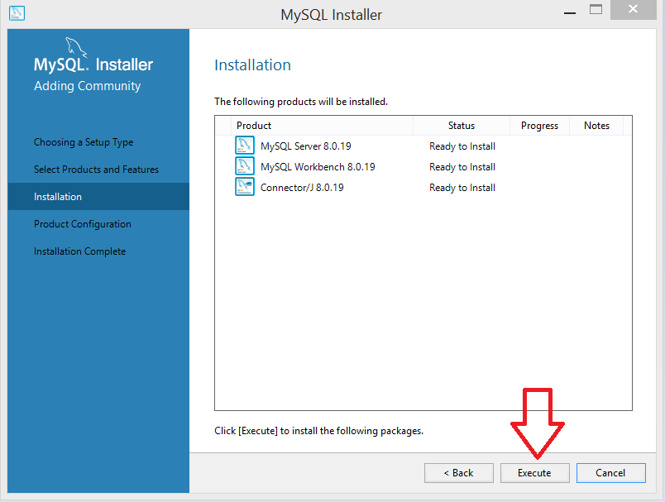computer. Hit “*Execute”*.
   4. Once you complete the installation, hit “*Next*.”

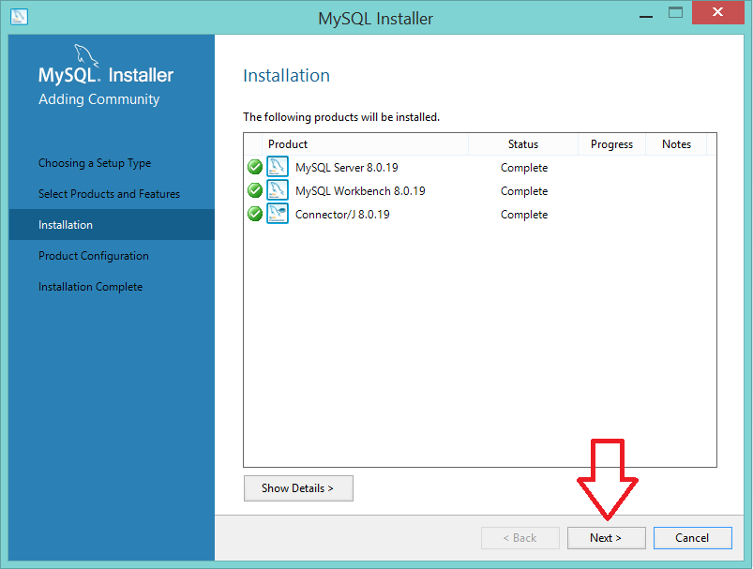

* 1. The Installer starts the MySQL configuration wizard. Hit “Next.”

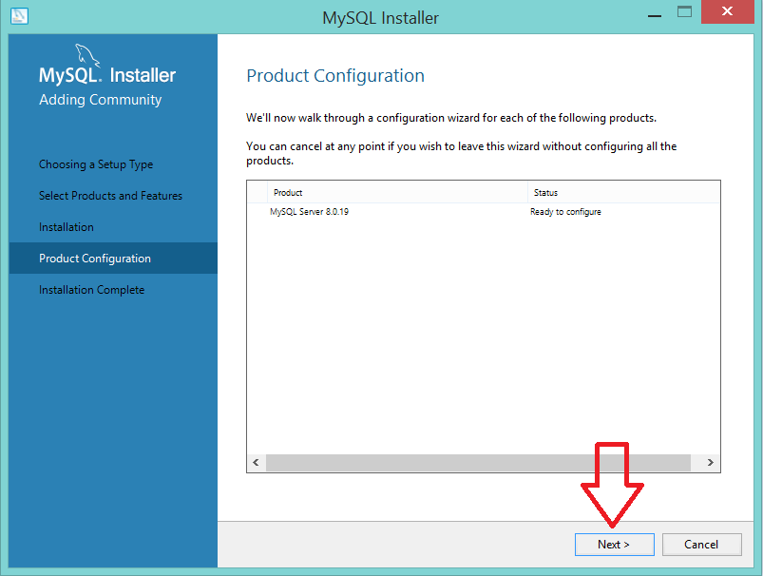

* 1. Select the Standalone option. Hit “*Next*.”

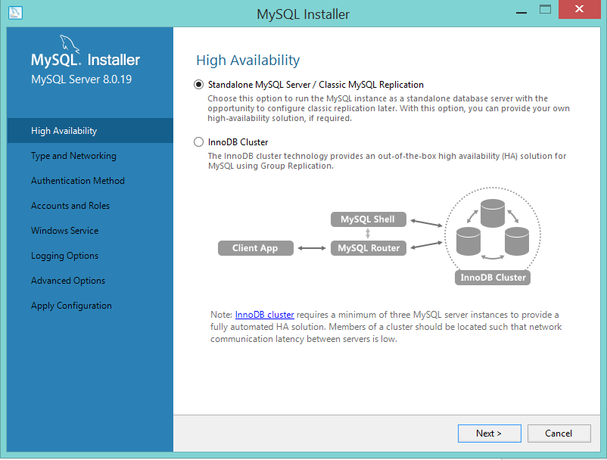

* 1. Keep the default settings. Hit “*Next*.”

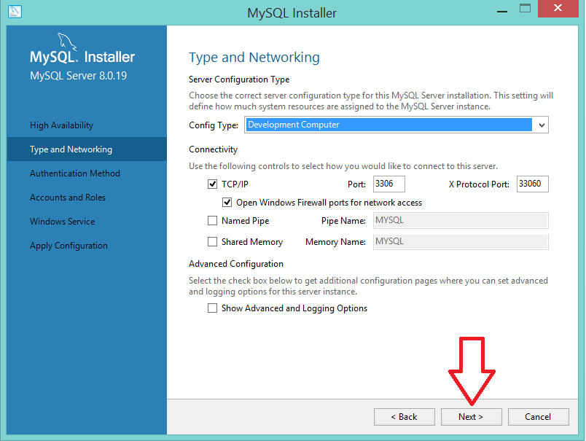

* 1. Keep the default settings. Hit “*Next*.”

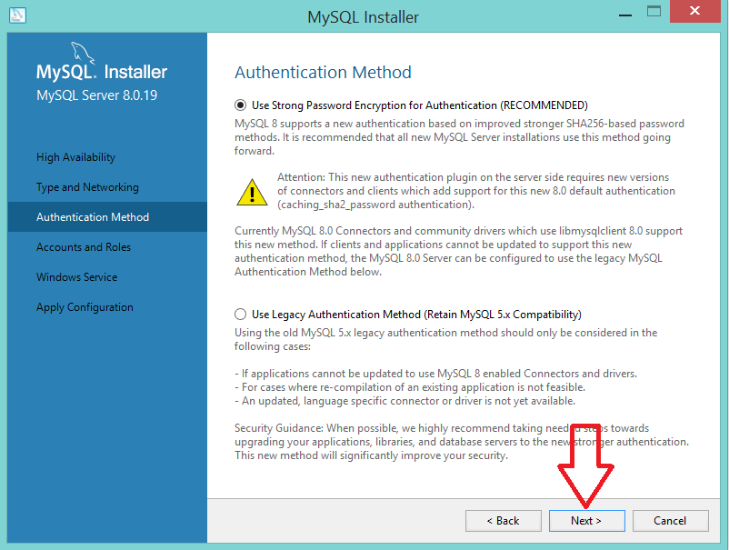

* 1. Set the administrator’s database password. Ensure the password is easy to remember 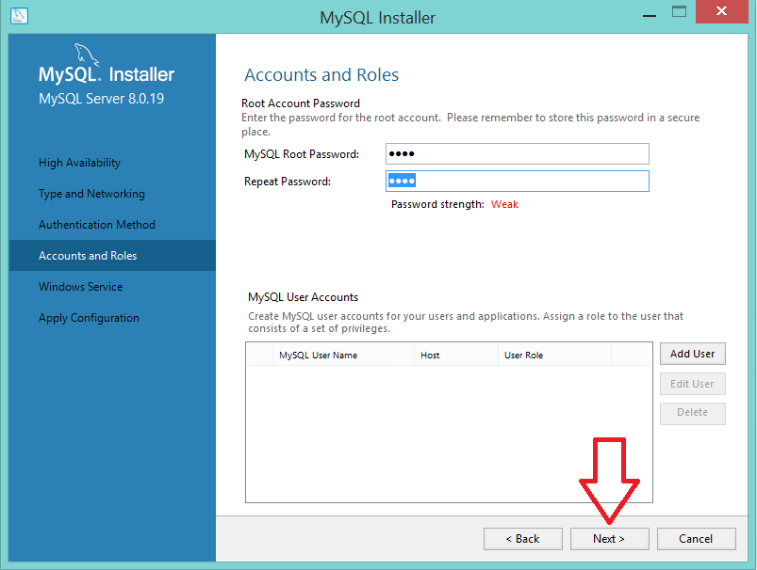or store it in a safe place as you will need it later. Hit “*Next*.”
  2. Keep the default settings. Hit “*Next*.”

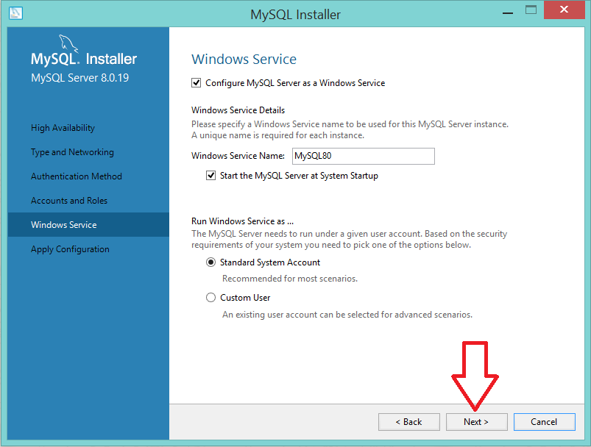

* 1. Apply the configuration. Hit “*Execute*.”

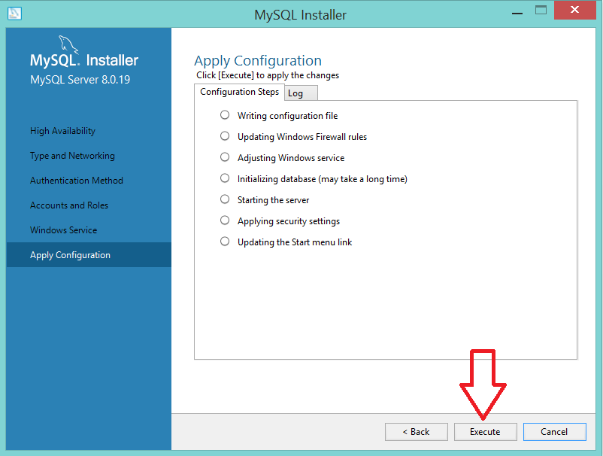

* 1. Once the configuration completes. Hit “*Finish*.”

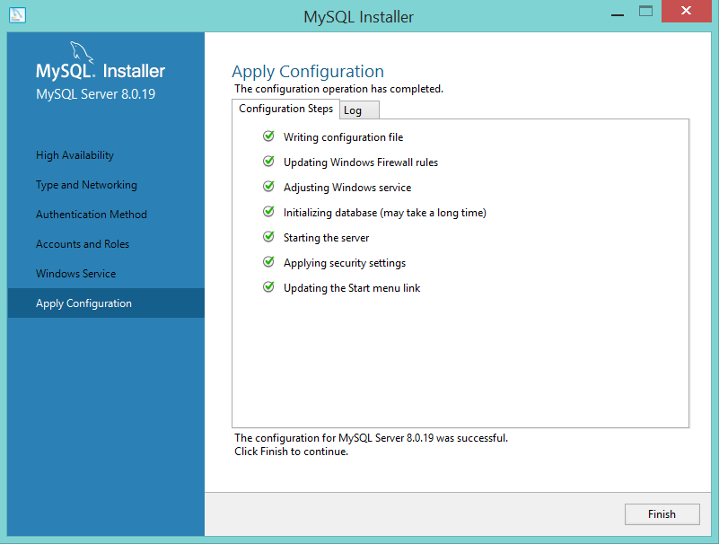

* 1. Hit “*Next*”.

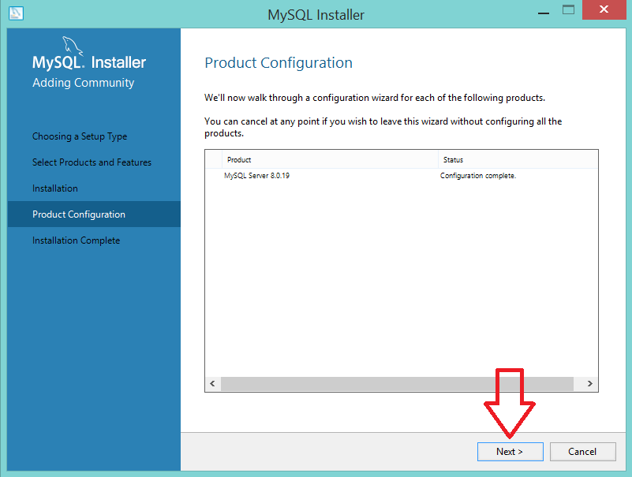

* 1. Once you completed the MySQL installation. Check off the “*Start MySQL Workbench*” option if you don’t want it at this time. Hit “*Finish*.”

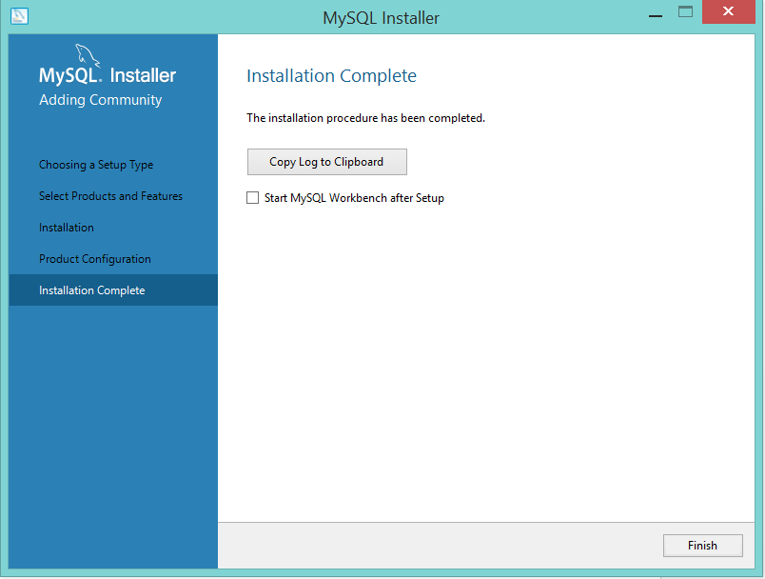

1. Verify the MySQL Community Server Installation.
   1. Go to Programs/MySQL and run “MySQL 8.0 Command Line Client”. 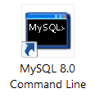
   2. Input the administrator’s password you created in step 2.9.

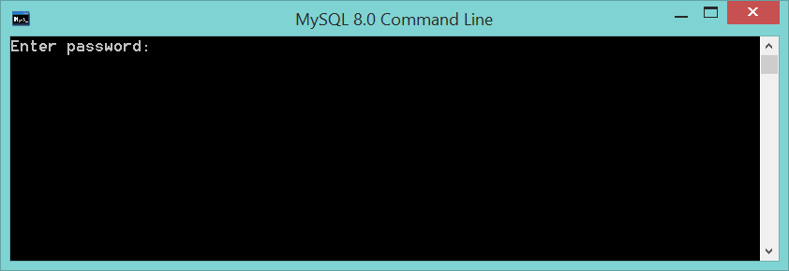

* 1. After the MySQL command prompt shows up, type “*show databases;*” without the double quotes marks and hit enter (don’t forget the semi-colon at the end of each instruction).

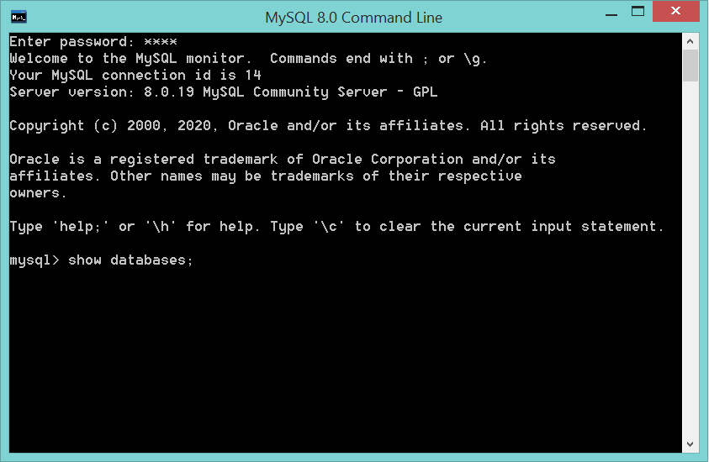

* 1. The list of databases is displayed. Type “*exit*;” without the double quotes marks and hit enter to close your session. Congratulations! Your installation was successful!

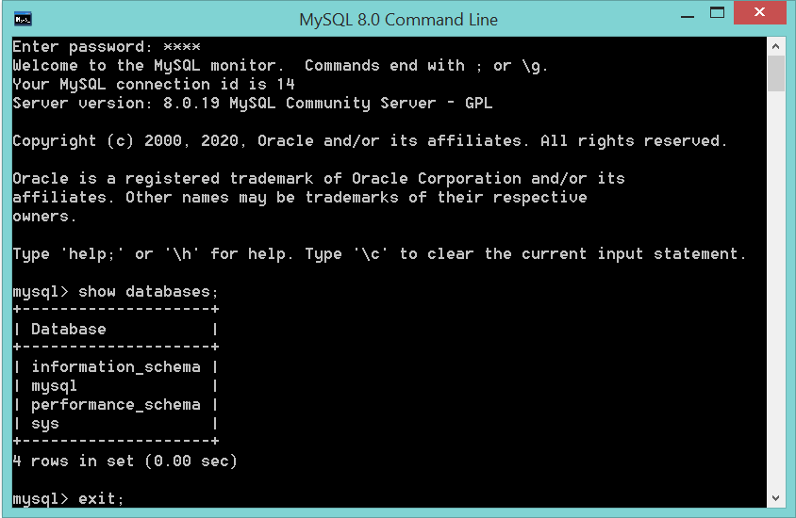  
  
// End